IR research
While creating the Nec parallel transmitter I have encountered with the interference problem of 2 transmitters when they stand near to each other, so I need to develop some protection to them, or something like guiding tube
My signal is Nec standard and has a carrier frequency of 38 KHZ, and the wavelength(of a transmission LED) is 940nm (3) so it defined as NIR region.
Here is the photo of the element
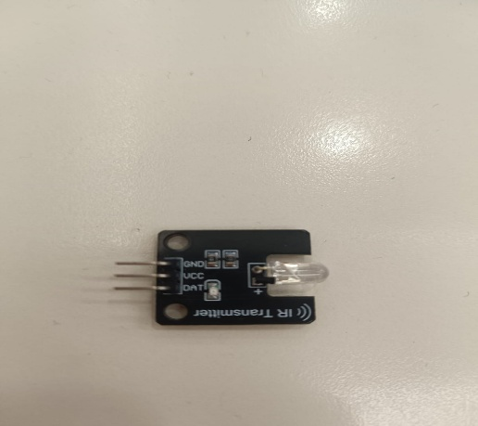
And the photo of regions(2):
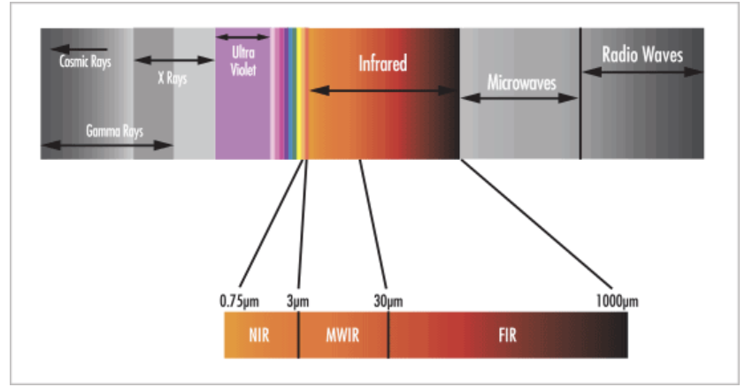
So I need some material that will reflect the IR light, so that they don’t interfere with each other, I searched for some materials that will bounce the material and one of common material is polished metals(4).I used the copper metal and it works properly for insulating.

References:
- https://medium.com/blueeast/nec-transmission-protocol-for-air-conditioners-67c8a698e633
- https://www.edmundoptics.com/knowledge-center/application-notes/optics/the-correct-material-for-infrared-applications/?srsltid=AfmBOorvoiugnx3GvH8vECmKRzjDPlJmNhuAdGI3hzvmdaas96Uk1zmx
- https://arduinomodules.info/ky-005-infrared-transmitter-sensor-module/
- https://carbodiimide.com/near-infrared-absorbing-materials-and-their-applications/

